The Course Project

The course project includes 4 parts.

Part 1:

The first part is to develop a Mapper and Reducer application to calculate average visibility distance (meters) for each USAF weather station ID from NCDC records (note: 999999 indicates missing value, and [01459] indicate good quality value).

**Command to execute python code with Hadoop streaming:**

[student57@msba-hadoop-name Project]$ hadoop jar hadoop-streaming-2.7.3.jar -file /home/student57/Project/mapper1.py -mapper /home/student57/Project/mapper1.py -file /home/student57/Project/reducer1.py -reducer /home/student57/Project/reducer1.py -input /home/57student57/Project/Data/ -output /home/57student57/Project/Part1_Output/

**MapReduce job execution:**

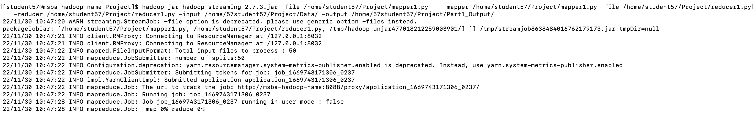

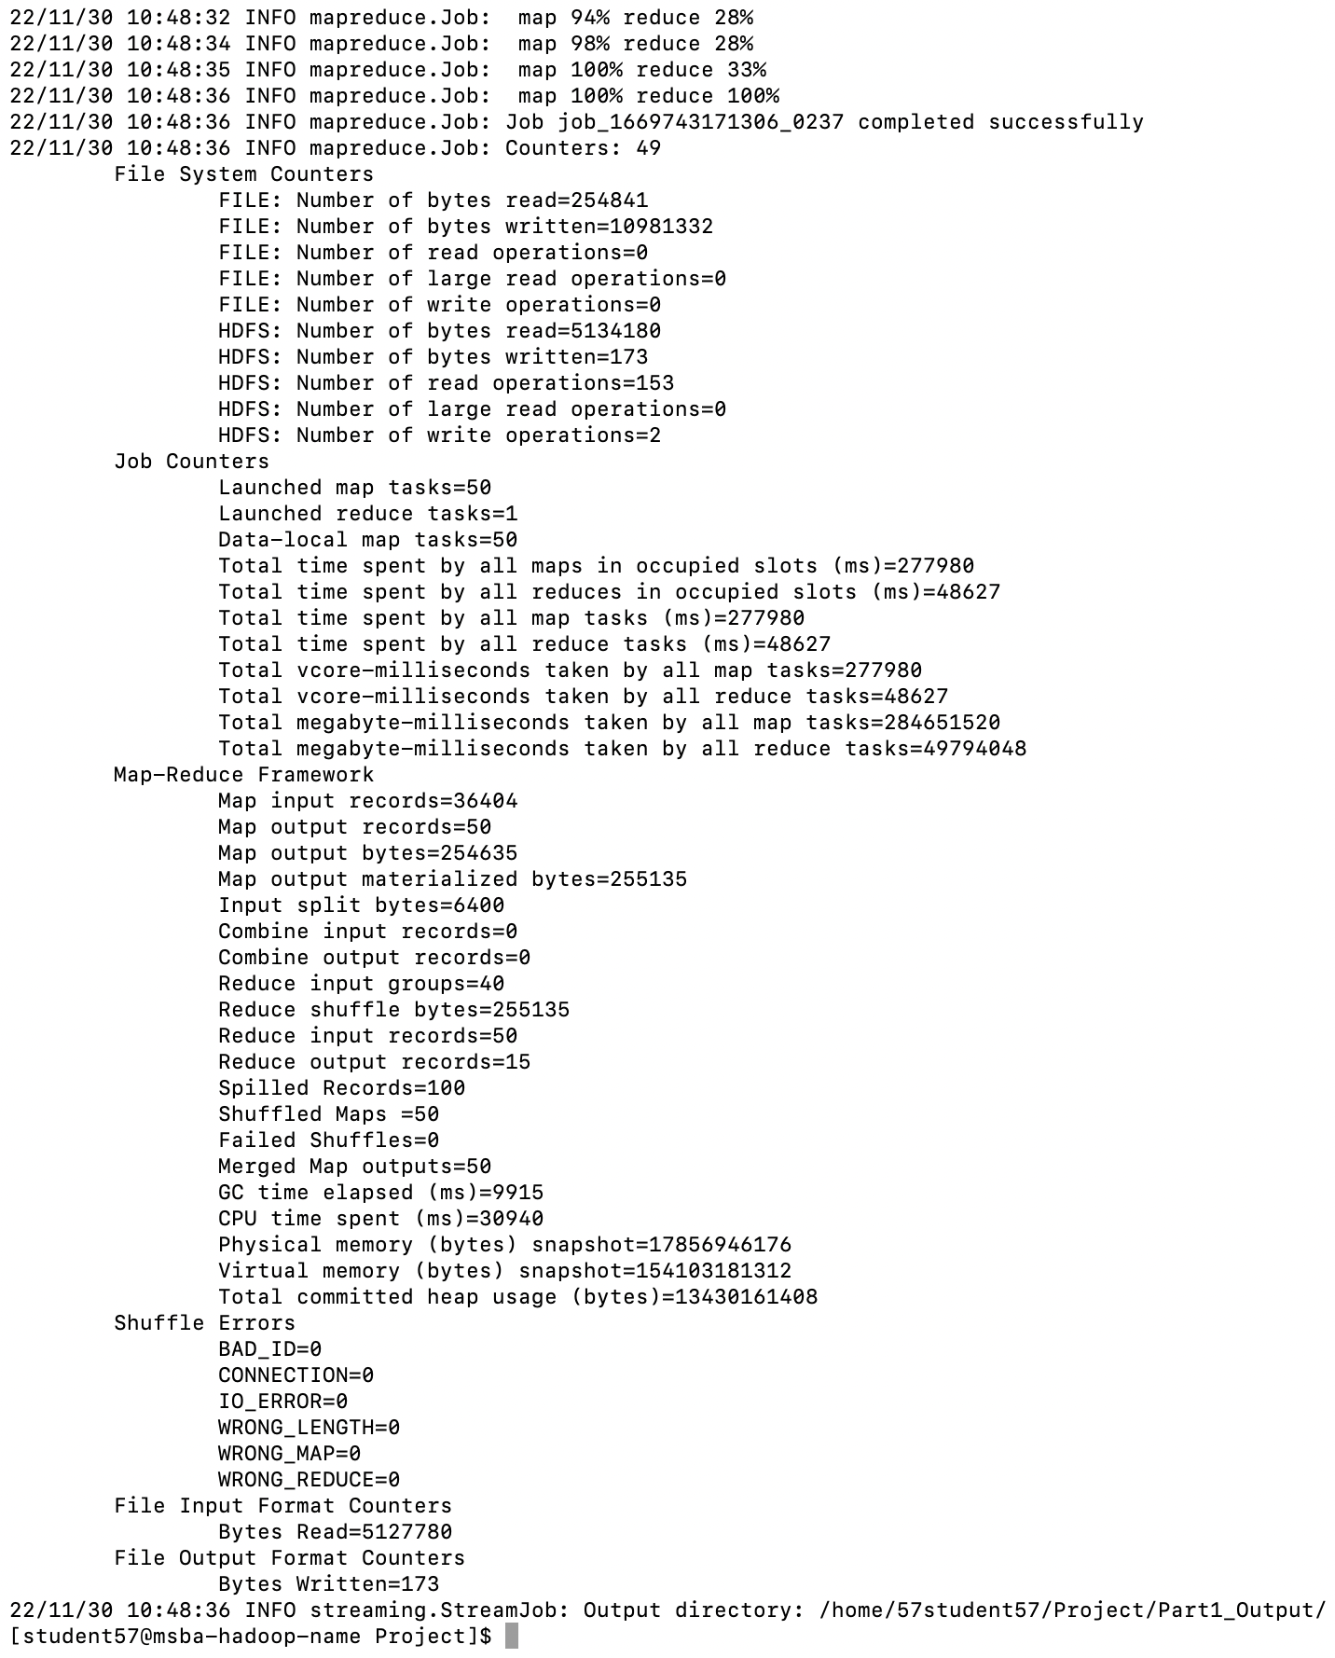

**Output:**

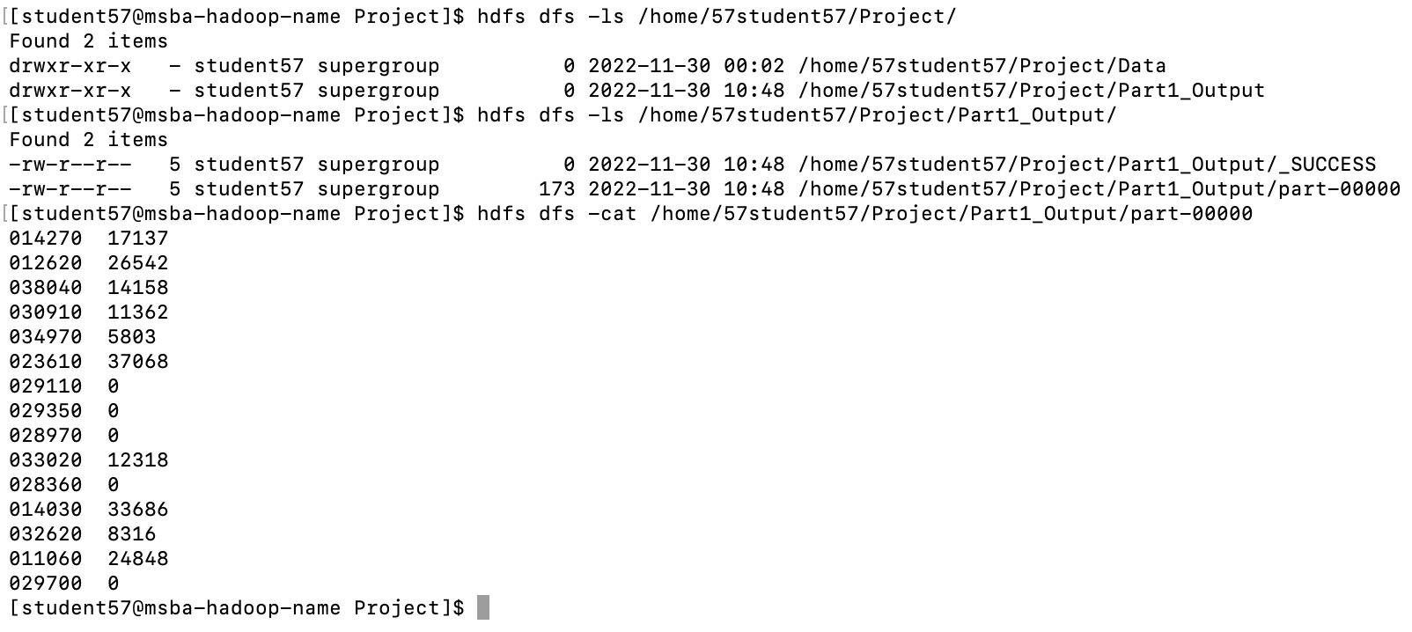

Part 2:

The second part is to develop a Mapper and Reducer application to retrieve USAF weather station ID and sky ceiling height (meters) from NCDC records (note: 99999 indicates missing value, and [01459] indicate good quality value) and then write the USAF weather station ID and sky ceiling height data into a text file.

**Command to execute python code with Hadoop streaming:**

[student57@msba-hadoop-name Project]$ hadoop jar hadoop-streaming-2.7.3.jar -file /home/student57/Project/mapper2.py -mapper /home/student57/Project/mapper2.py -file /home/student57/Project/reducer2.py -reducer /home/student57/Project/reducer2.py -input /home/57student57/Project/Data/ -output /home/57student57/Project/Part2_Output/

**MapReduce job execution:**

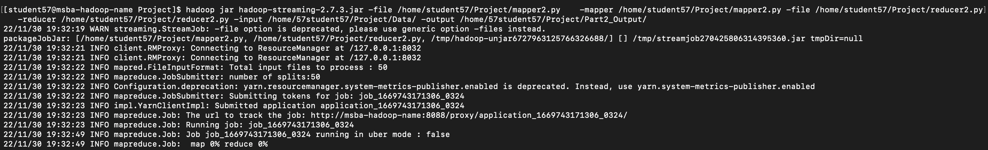

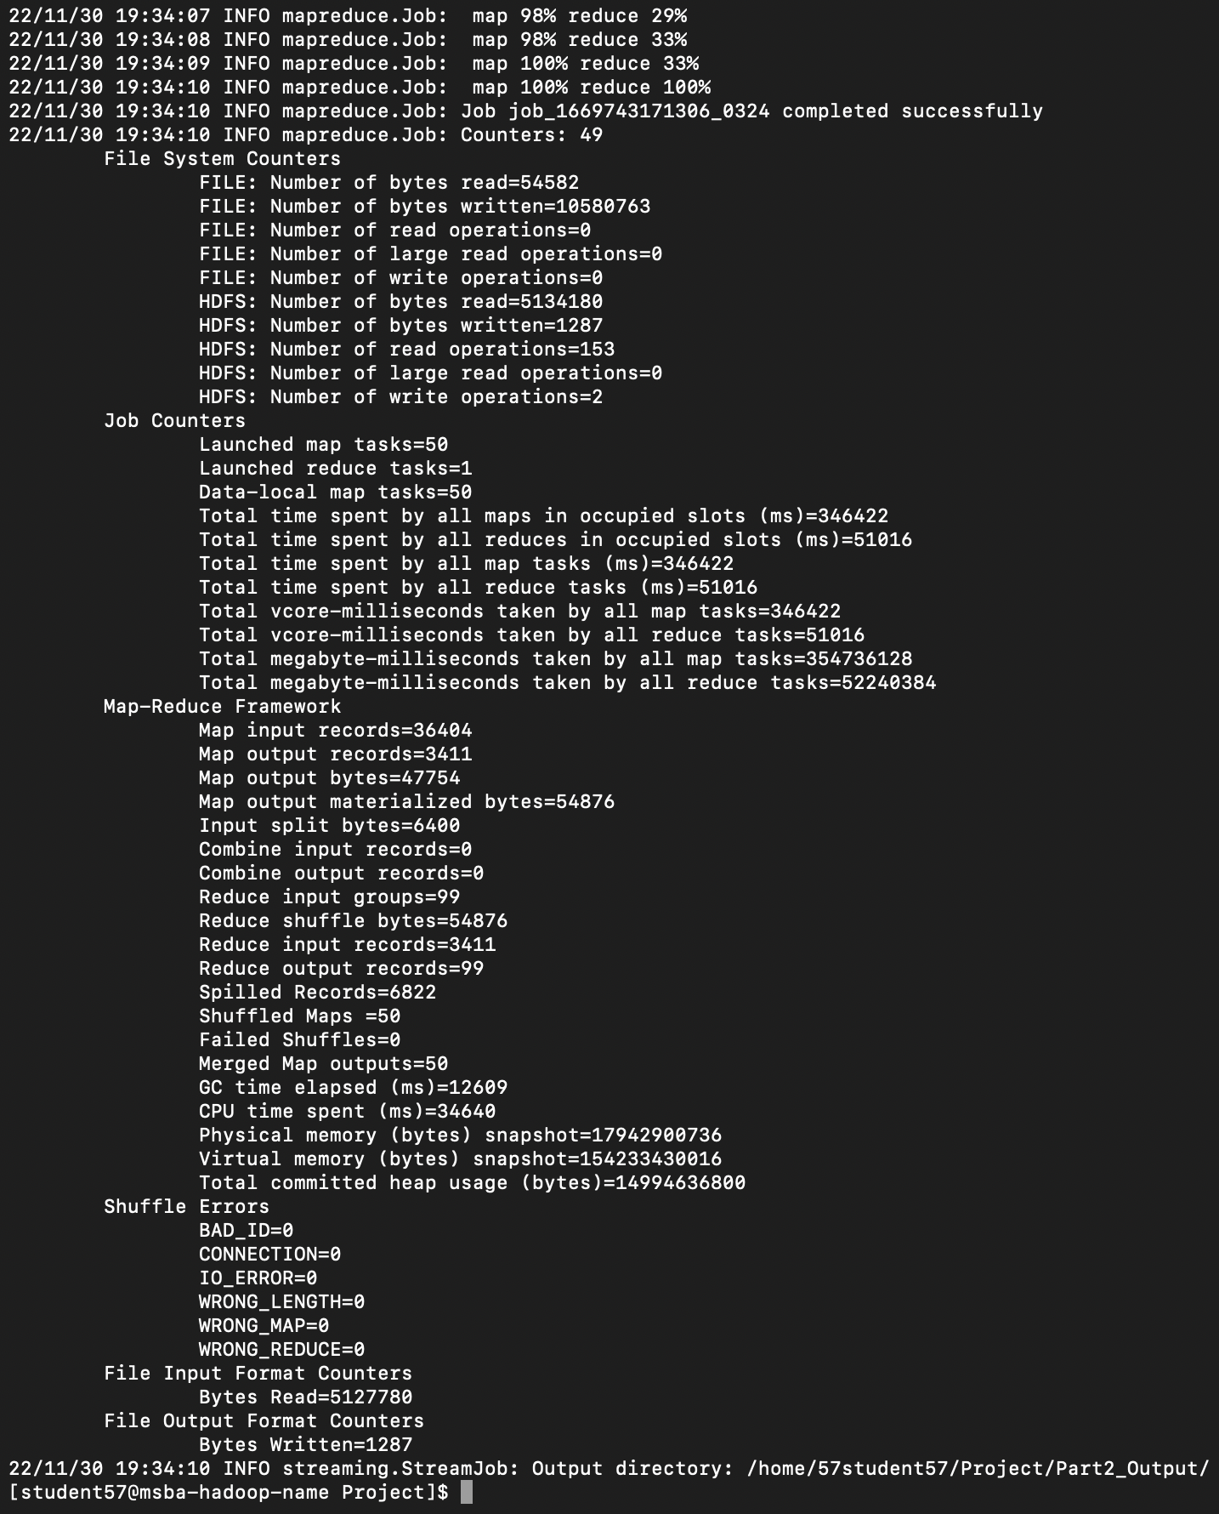

**Output:**

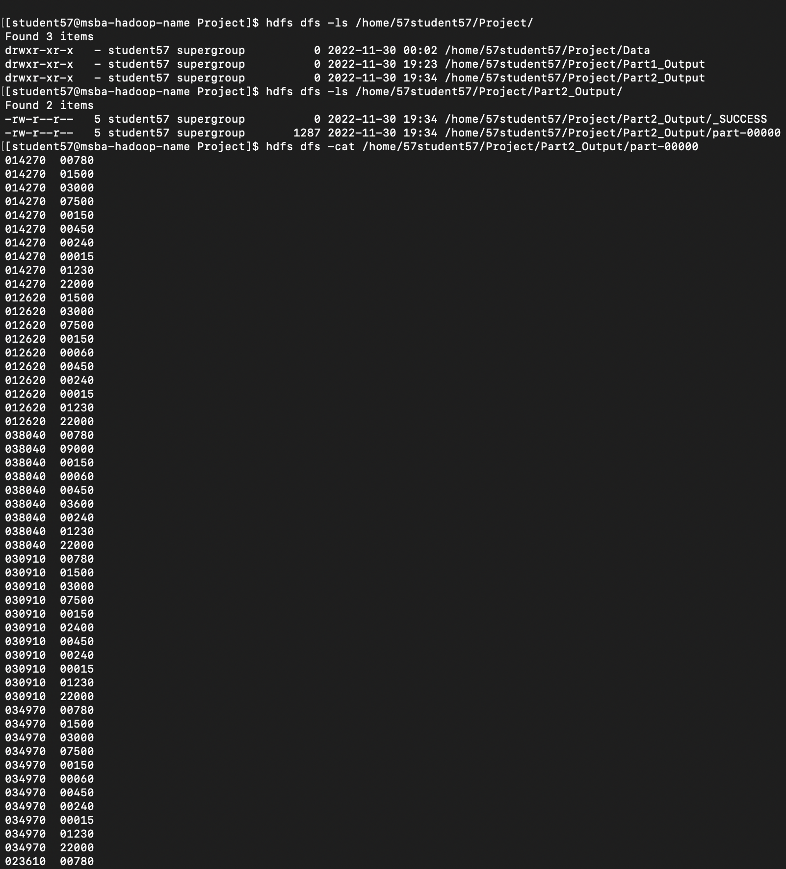

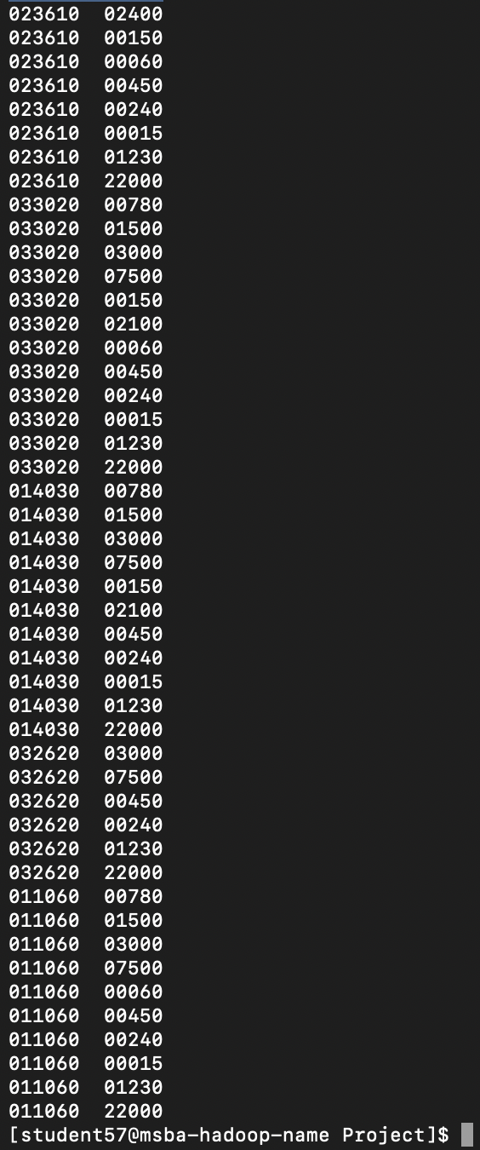

**Converting the map-reduce output to a text file:**



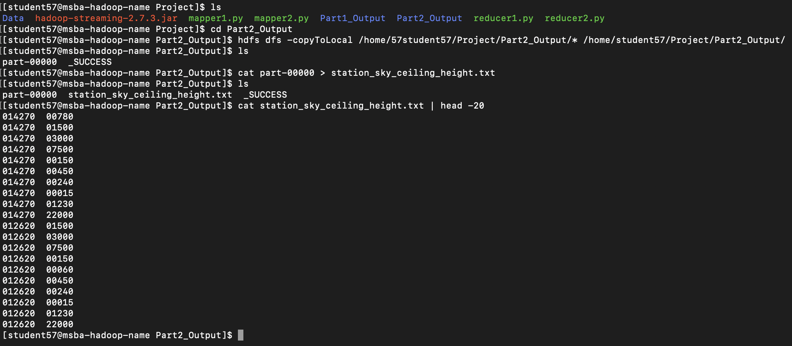

(Note: There are duplicate combinations of station_id and sky_ceiling_height are present when we consider records from all data files, only unique combinations of are selected from all the files. As keeping duplicates will give wrong average sky_ceiling_height)

Part 3:

The third part is to load the text file into Pig and get the average sky ceiling height for each USAF weather station ID.

**Loading data into Pig:**

grunt> station_height = LOAD 'Part2_Output/station_sky_ceiling_height.txt' AS(station:chararray, height:int);

grunt> DUMP station_height;

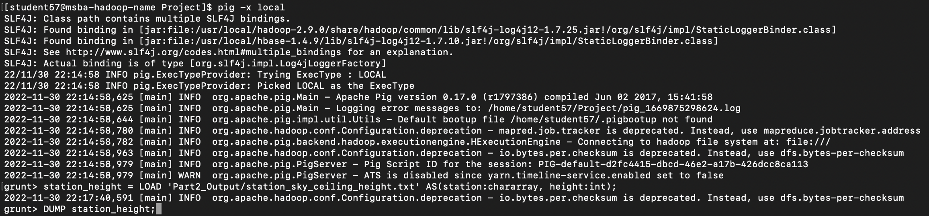

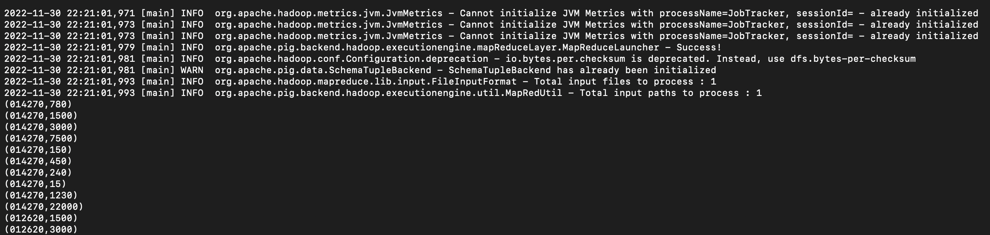

**Grouping records by Station:**

grunt> st_grouped_height = GROUP station_height BY station;

grunt> DUMP st_grouped_height;



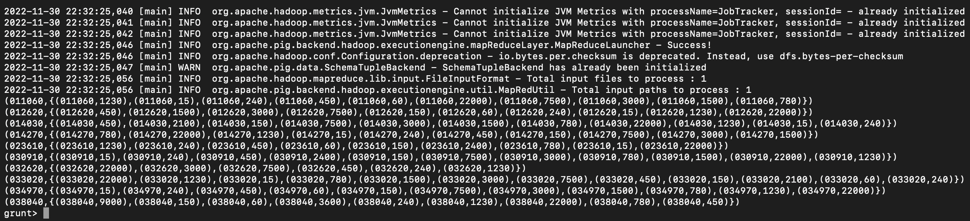

**Calculating average height for each station:**

grunt> st_avg_height = FOREACH st_grouped_height GENERATE group, AVG(station_height.height);

grunt> DUMP st_avg_height;



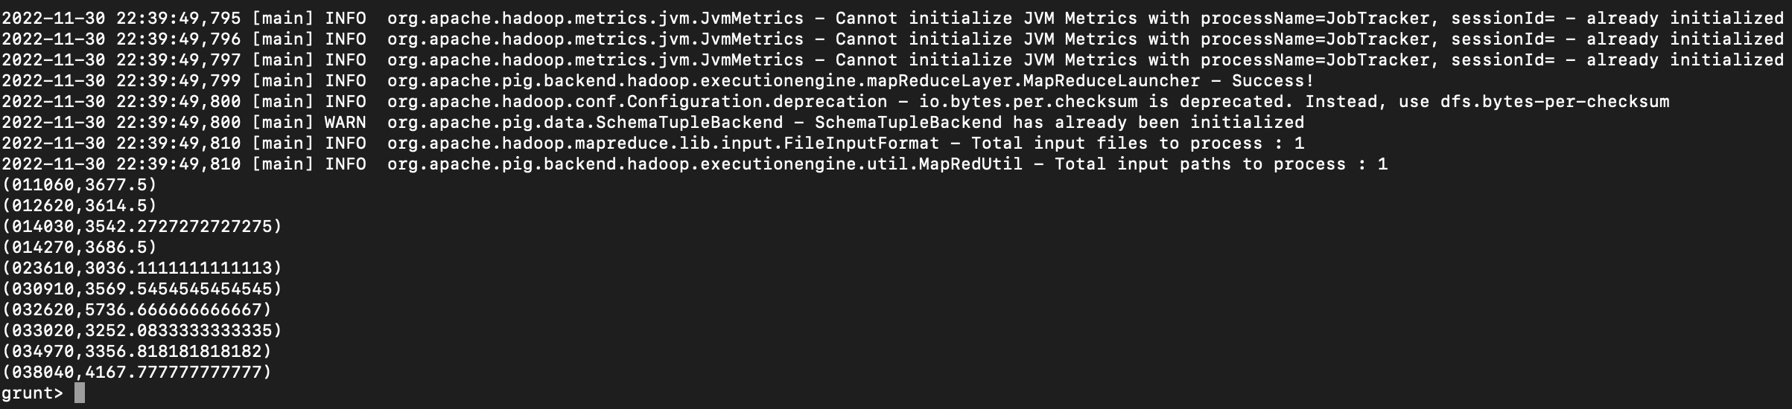

Part 4:

The fourth part is to load the text file into Hive and get the highest and lowest sky ceiling height for each USAF weather station ID.

**Creating table and loading data in HIVE:**

CREATE TABLE Station_Height_57 (station STRING, height INT) ROW FORMAT DELIMITED FIELDS TERMINATED BY '\t';

LOAD DATA LOCAL INPATH 'Project/Part2_Output/station_sky_ceiling_height.txt' OVERWRITE INTO TABLE Station_Height_57;

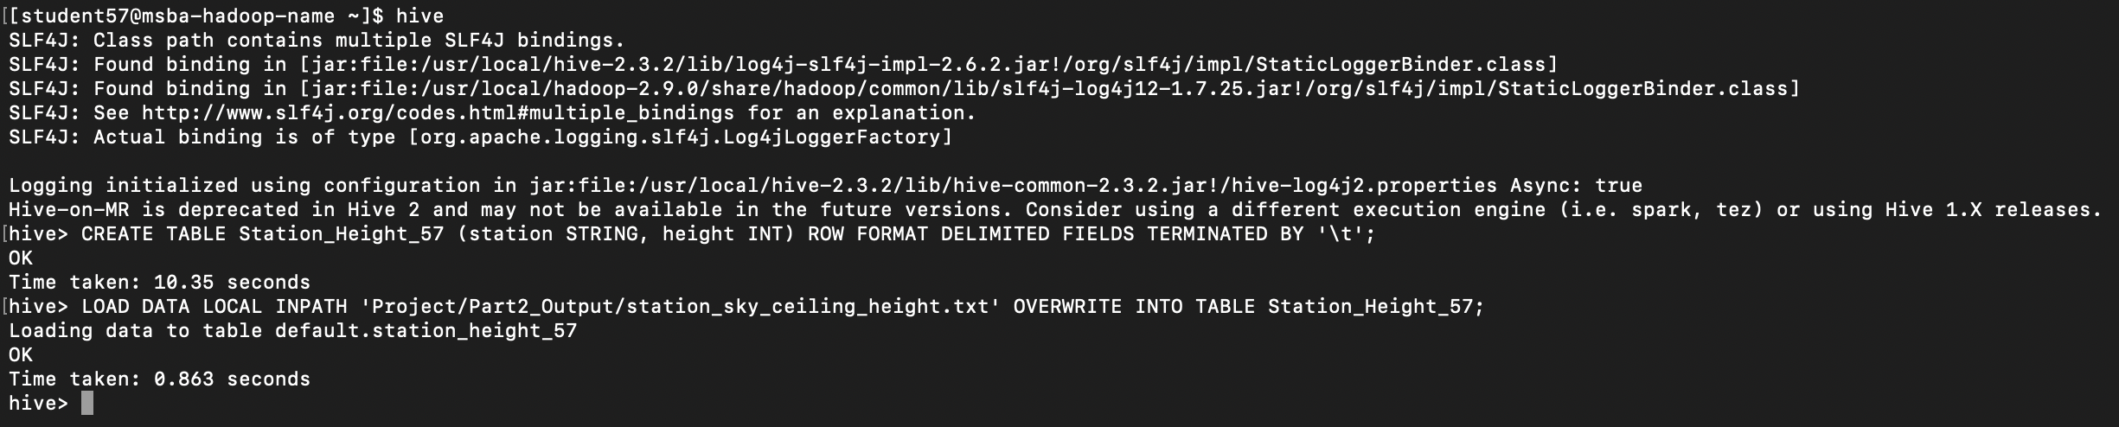

**Querying HIVE table to get the highest, lowest sky ceiling height for each weather station:**

SELECT station, MAX(height), MIN(height) FROM Station_Height_57 GROUP BY station;

